

ASUMBI GIRLS’ 2025 PREDICTION
CONFIDENTIAL KCSE EXAM
231/3
BIOLOGY
PAPER 3 (PRACTICAL)
TIME: 1¾ HOURS

NAME……………………………………………………………………………………….
SCHOOL……………………………………………… SIGN………………………..
INDEX NO……………………………………………. ADM NO……………………
(Kenya Certificate of Secondary Education)
INSTRUCTIONS TO CANDIDATES
- Answer all the questions in the spaces provided
- You are required to spend the first 15 minutes of the 1$3/4$ hours allowed for this paper reading the whole paper carefully before commencing your work. Answers must be written in the spaces provided in the question paper. Additional pages must not be inserted.

FOR EXAMINERS USE ONLY
Question | Maximum score | Candidate’s score
1. | 19
2. | 13
3. | 08
Total score | 40

1. You are provided with specimen labeled K, L and M. Examine the external features of the specimens and answer the questions that follow.
a) Giving a reason, identify the type of fruit represented by; (4mks)
Fruit | Identity | Reason
K
L

b) Carefully open specimen K longitudinally to expose the inner parts.
i) State the type of placentation in the specimen. (1mk)
………………………………………………………………………………………………………

ii) State the mode of dispersal of specimen K and M.
K (1mk)
………………………………………………………………………………………………………

M.(1mk)
………………………………………………………………………………………………………

iii) Draw and label specimen M. (2mks)

c) Make a transverse section of specimen L, cutting it into two equal halves.
i) Identify the type of placentation in specimen L. (1mk)

ii) Slice off about 3cm thick disc from the specimen and peel it. Place the piece on a white tile and smash it into a paste using the glass rod provided. Put the paste into a 100ml beaker followed by 20ml of distilled water and stir. Transfer the contents into the visking tubing provided and tie it tightly on both ends using the threads provided. Ensure there is no leakage at both ends of the visking tubing. Rinse the outside of the tubing with water. Immerse the visking tubing with its contents in a 100ml beaker containing iodine solution. Allow the set-up to stand for 20minutes. Record your observations in the table below. (4mks)
Experiment | Extract inside the visking tubing | Iodine solution outside the visking tubing
Before the experiment

After the experiment

d) Which physiological process was being investigated? (1mk)
………………………………………………………………………………………………………

e) Account for the results obtained from the table above. (4mks)
………………………………………………………………………………………………………
………………………………………………………………………………………………………
………………………………………………………………………………………………………
………………………………………………………………………………………………………
………………………………………………………………………………………………………

2. You are provided with photographs labeled 1, 2 and 3. Use them to answer the questions that follow.
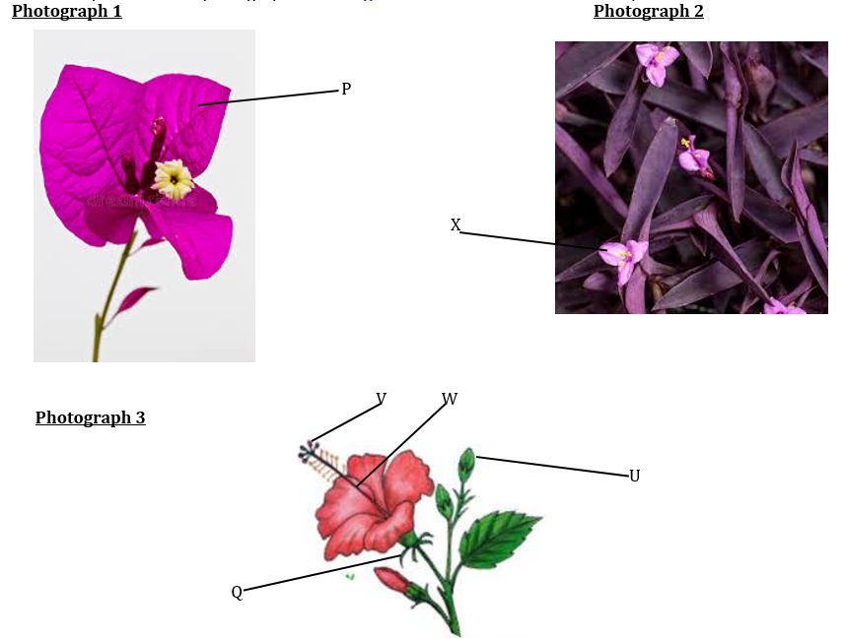
a(i) State the division and sub-division which the photographs belongs to; (2mks)
Division………………………………………………………………………………………………
Sub-division…………………………………………………………………………………………

ii) Give a reason for your answer in a(i) above. (1mk)
………………………………………………………………………………………………………
………………………………………………………………………………………………………

b) Identify the class that specimen in photograph 2 belongs to and give a reason for your answer. (2mks)
Class…………………………………………………………………………………………………
Reason
………………………………………………………………………………………………………
………………………………………………………………………………………………………
………………………………………………………………………………………………………

c) With a reason, suggest the agent of pollination for the three specimens. (2mks)
Agent……………………………………………………………………….
Reason……………………………………………………………………………………………………………………………………………………………………

d) Identify the parts labeled V, W and P. (3mks)
V………………………………………………………………………………………………
W……………………………………………………………………………………………..
P………………………………………………………………………………………………

e(i) Identify the developmental stage represented by U………………………………………………………………………… (1mk)

ii) State the significance of the part labeled Q (1mk)

f) Describe the floral parts labelled X (1mk)

3. Using a scalpel, obtain three peeled cubes from specimen S measuring about 1cm by 1cm by 1cm. For the first cube, you are required to boil it in water for five minutes. For the second cube, you are required to crush it into a paste. For the third cube, you are required to use it as it is.

Label three test tubes A, B and C and put 2ml of hydrogen peroxide in each test tube. To test tube A, add the boiled cube and record your observation.
To test tube B. add the crushed paste and record your observation.
To test tube C, add the third cube and record your observation.

- Complete the table below (3marks)
Test tube | Observation
A
B
C

- Explain your observation in test tube A (1mark)
………………………………………………………………………………………………………
………………………………………………………………………………………………………

- Between test tubes B and C, in which test tube was the volume of foam produced the highest? Explain (3marks)
………………………………………………………………………………………………………
………………………………………………………………………………………………………
………………………………………………………………………………………………………
………………………………………………………………………………………………………
………………………………………………………………………………………………………

- Apart from temperature, state one other factor that affect the rate of enzyme controlled reactions (1marks)
………………………………………………………………………………………………………
………………………………………………………………………………………………………

